Contents

Chapter 1 3

Introduction 3

1.1 Project Introduction 3

1.2 Project Background 3

1.3 Overview of Project 3

1.4 Features of Project 3

1.5 Aims and Features of Project 4

Chapter 2 Analysis 5

2.1 Introduction to Analysis 5

2.2 Analysis Methodology 6

2.3 Feasibility Study 11

2.4 Requirement Analysis 12

2.4.1 Functional Requirement 12

2.4.2 Non-Functional Requirement 13

2.4.3 MoSCoW Prioritization 15

2.4.4 System Requirement Analysis 18

2.5 Use Case Diagram 19

2.6 NLA and Initial Class Diagram 23

Chapter 3 25

Design 25

3.1 Structural Model 25

3.1.1 Final Class Diagram 26

3.1.2 Flow Chart Diagram 27

3.2 Behavioral Model 31

3.2.1 Activity Diagram 31

3.2.2 Sequence Diagram 35

3.3 Database Modeling 40

3.3.1 Data Dictionary 40

3.3.2 ER Diagram 41

3.4 Architectural Diagram 43

3.5 Prototype 44

Chapter 4 50

Coding 50

4.1 Introduction 50

Chapter 5 62

Testing 62

5.1 Introduction 62

5.2 Types of Testing 62

5.2.1 Black-Box Testing 62

Chapter 6 Issues 64

6.1 Project Issues 64

6.2 Limitation 64

6.3 Risk Management 64

6.4 Configuration Management 65

Chapter 7 Future Work 66

Chapter 8 User Manual 67

Chapter 9 Conclusion 67

References 68

# Chapter 1

# Introduction

## 1.1 Project Introduction

My project is about ABC Shoe Factory which deals in making or producing different types of shoes. After shoes are produced we distribute it to many shops and dealers. We don’t deal with customer directly.

This shoe factory produce many design of shoes. They also produce the copy of top brand of shoes like Nike, Adidas etc. I have asked to develop factory official website. Website will contain details of all the shoes that are produce in the factory. This project is only based on Nepal but this website does not have any region restriction so people or shop from any country can visit the site. This project will be focusing on customer satisfaction and advertising the shoe produce in factory not only in Nepal but all over the country.

## 1.2 Project Background

This factory only deals shoes in Nepal but it does not have better information system to advertise its product to Nepal only also. There are many districts in Nepal where many peoples living together. So among them there are some rich people, average peoples and poor people. According to their status they will buy shoes. All people cannot afford the expensive shoes and 90% of people from villages, urban areas definitely cannot afford expensive shoes.

So I am designing new website which will have new online order system. So shop form urban areas or villages can check the details and price of all the shoes and place order according to what design of shoes and how much shoes people can afford of that place/area/villages etc.

## 1.3 Overview of Project

This project will be focused on customer satisfaction and gaining more profit. This project will help what kind of shoes they need according to how much they can afford. This project is also about advertising its product all over Nepal as well as to other countries also so that they can check the details of all shoes online.

## 1.4 Features of Project

* Shop can place the order online.
* Business will earn more profit.
* Customer will be satisfied.
* New design of shoes.
* Very cheap shoes will be available in urban areas.
* Commenting and Rating online or in Paper.
* Customer can directly send the message or mail to factory if they get any negative impact from shoes.
* Even people from another country can visit the website and check the details of shoes.

## 1.5 Aims and Features of Project

Aims

* To make online ordering facility so that they can place order in which design of product they are out of stock.
* To make user friendly website for people to check details of shoes.
* Make the customer fully satisfy.

Objectives

* Administrational login system to add the new product with details.
* Online ordering system will be created by filling online form which will be available in factory official website.
* Creating user friendly website with adding many pictures and icons rather than text.
* Customers can check all the details of shoes in factory website before buying in shops so they will feel secure.
* New shops who don’t have contract with this factory can make contract by filling the online form to place order.

# Chapter 2 Analysis

## 2.1 Introduction to Analysis

It is one of the very important phase while making some products or projects. Without analysis our project/products is bound to fail. Simply it is the process of dividing the topics into different parts to get better knowledge of it. It is the phase where we must find what user needs and collecting all data to make better or improve the made product.

Features of analysis in my project are as follows:

* It is very important to proceed our project further.
* In helps in collecting data on project.
* It is the place where system analysis takes place.
* Helps in analyzing the need of end user so that the new system or upgraded system will meet the expectation of end user.
* It helps to find what problem user are facing.

## 2.2 Analysis Methodology

It is a systemic, theoretical analysis of methods applied to field of study. It also incorporates the concepts such as quantitative or qualitative techniques, paradigm, phases etc. There are different type methods in software development like soft system methodology, hard system methodology, etc. Among all of the methods I have decided to use the Soft System Methodology.

Soft System Approach (SSM)

It is a way to deal organizational process modelling and also it can be used for both general problem solving and the change of management. It was developed by academics at University Of Lancaster in System department for 10year action research program in England. It is the most used method and practical application of system thinking. The primary use of SSM is done in case of analysis needed in complex situation. These situations are soft problems like: What system need to do? And how will it do? Etc.

SSM is processed in several types of steps as follows:

1. Problem Finding

It is the stages where we find what problems are there now so that we can minimize or fully solve in this new projects. As we get details from ABC Shoe Factory they have many problems in their system right now. We can also do interview, do survey to find more problems. As I checked into their current site:

* Their system is not well responsive.
* They don’t have many online facilities right now.
* Customers and Visitors can’t get proper details of shoes.

1. Expressing The Problem Situation

This stages involves the communication and validation of investigator’s ideas about problem situation. There are many various tools which can used to check the investigator’s ideas but the main technique is drawing the Rich Picture. Rich Picture is a part of SSM that provide mechanism for learning complex problems by detailed diagram. Rich Picture for my project is as follows:

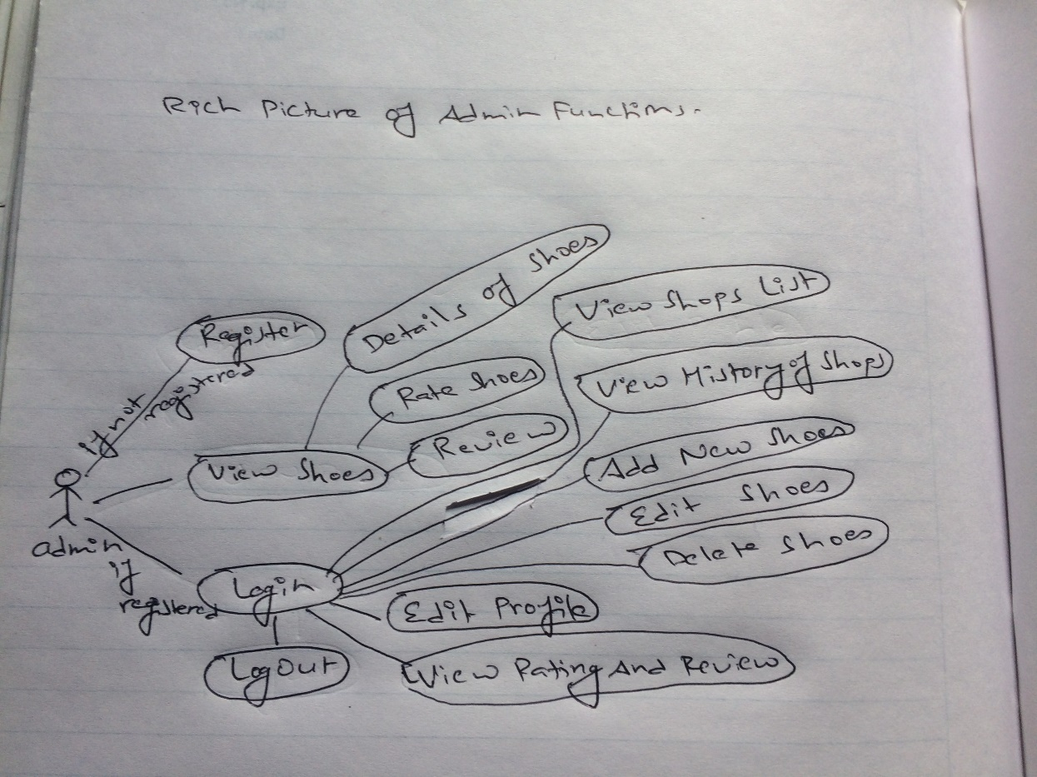

Diagram: Admin Function RP

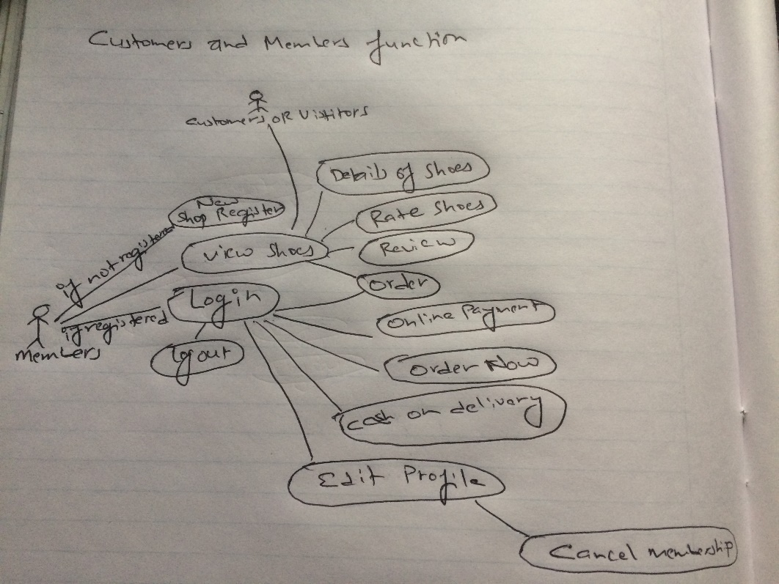

Diagram: Members and Visitors Function RP

1. Deriving Root Definitions Of Relevant Systems

Root Definition is the purpose of system of human activity. System of human activity never has a single purpose. It have two steps involved in producing root definitions:

Input, Output transformation Diagrams = what the system is to achieve or change

CATWOE framework = to produce Root Definition for each transformation

The first step in a CATWOE analysis is identifying such**customers** and understanding how the **process** or system affects them.

CATWOE analysis is about identifying customers and shop members and knowing how the system process affects them.

CATWOE stands for:

C= Customer

A=Actors

T= Transformation Process

W= Worldview

O= Owner

E= Environmental Constraints

1. Deriving Conceptual Models

Deriving Conceptual Model is a process of analyzing the activities which must be involved to clearly define what actors must do to achieve results. We don’t have to include activities which will be not done by actors.

The Conceptual Model prepared for my project is as follows:

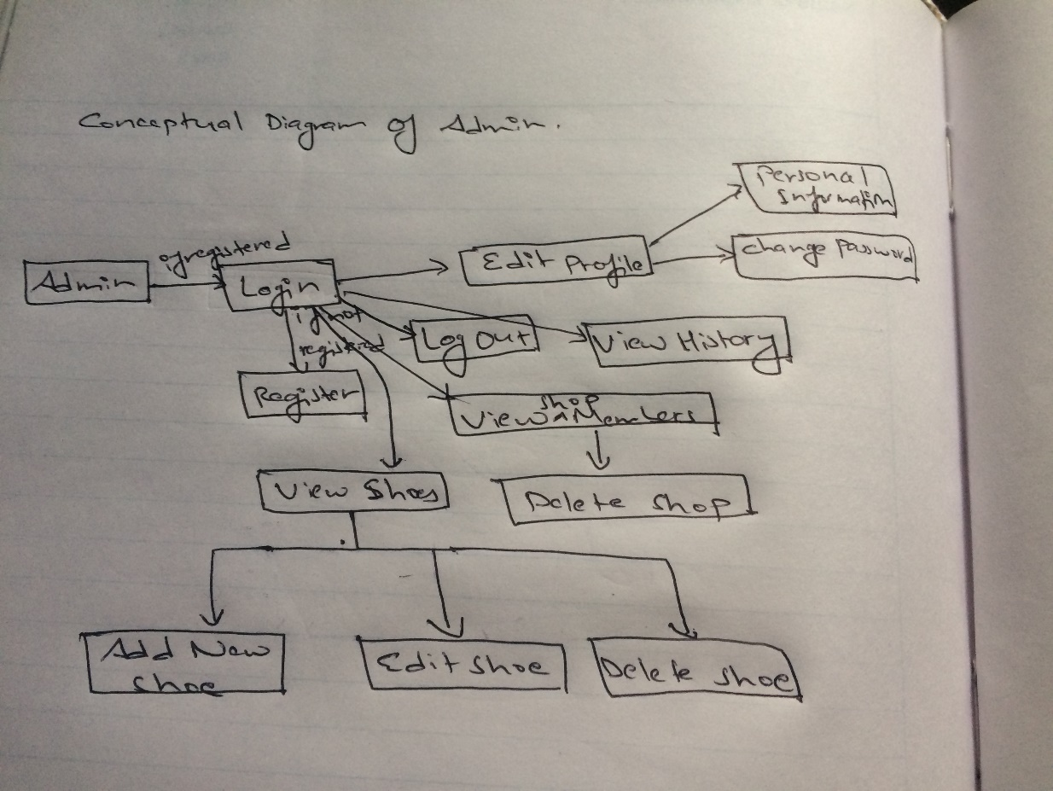

Diagram: Conceptual Model Admin

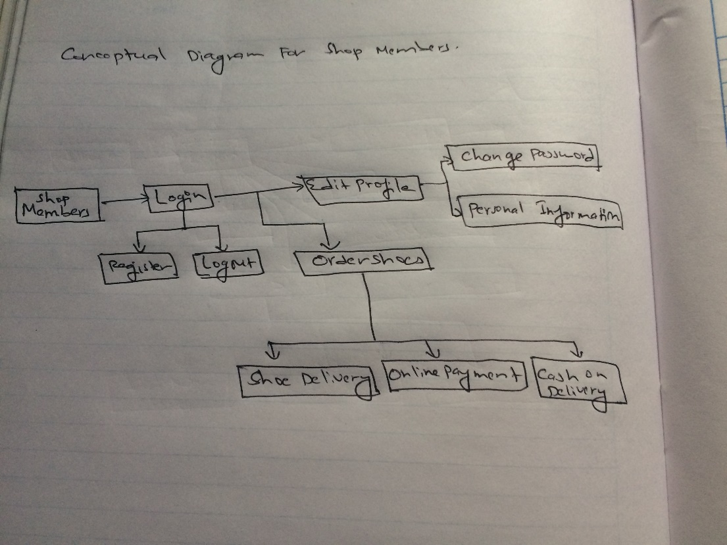

Diagram: Conceptual Model Members

1. Comparing Conceptual Model in Real World.

The best thing of SSM is that we are never allowed to forget that our model does not represent the real world. This steps compares the Conceptual Models with the real time project.

|  |  |
| --- | --- |
| Conceptual Model | Real World |
| All the shops can register as member and place the order for shoes. | This Project is only based on Nepal so for now only shops from Nepal can place orders. |
| Orders will be delivered in the requested time. | If some problem arises orders might not be delivered in time. |

## 2.3 Feasibility Study

After the proposal is accepted the next phase we do is to examine the feasibility of the system. Feasibility Study is the test of proposed system in its workability, user’s requirements, effective use of resources etc. Project is called successful when we finish it in time with given budget and main goal of Feasibility Study is not to solve problem but to achieve the scope. Following decision are taken in different feasibility study:

|  |  |  |  |
| --- | --- | --- | --- |
| S/N | Feasibility Study | What does It Do? | Relation To Project |
| 1 | Economic Feasibility | If given Budget for Project will be feasible? | We don’t have to do extra spend in like GPS because location of shops will be fixed so given Budget will be feasible. |
| 2 | Time Feasibility | If the given time for project will be feasible? | As we have already developed WBS and Gantt chart to manage time so as long as project goes as planned it will be finished in time. |
| 3 | Operational Feasibility | If the project will be advantageous and solve the problems? | Project will help the shops to get which shoes they want in stock by selecting in site and it will help customers also to check details of shoes. |
| 4 | Technical and Resources Feasibility | Is current skills and resources are enough to complete the projects? | I have Good laptop with good internet connection to develop the project and my skill not professional but getting better with time. |
| 5 | Social Feasibility | Will project be accepted in society and cause any social issues or not? | My project is to make system for shoes factory which does not give any harm to society so it will be accepted. |

Table: Feasibility Study

## 2.4 Requirement Analysis

### 2.4.1 Functional Requirement

Functional Requirement is an essentially specifies something the system should do. Typically functional requirements are requirements or features which are arranged to include system or program to be made.

The functional requirements that are needed in my project are listed in table below:

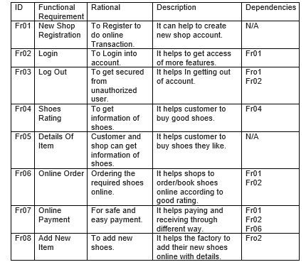

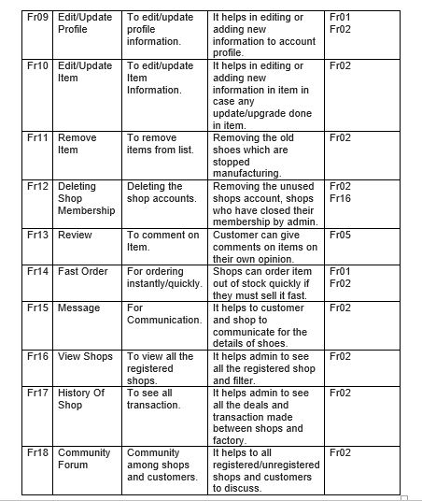

Screenshot: Functional Requirements

### 2.4.2 Non-Functional Requirement

Non-functional requirement is that it essentially specifies how the system should behave and it’s a constraint upon systems. It is also quality attributes of a system. It cover all the remaining requirement which are not covered by the functional requirement.

The Non-Functional requirement for my project are listed in table below:

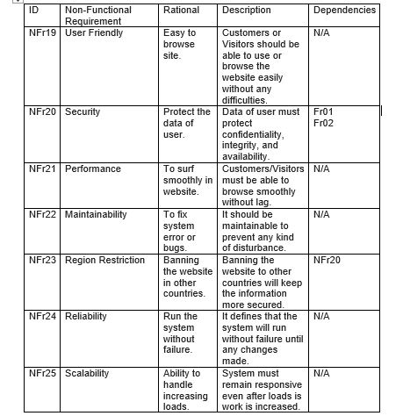

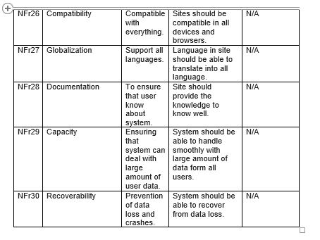

Screenshot: Non-Functional Requirements

### 2.4.3 MoSCoW Prioritization

MoSCoW prioritization also known as the MoSCoW method or MoSCoW analysis is popular technique for arranging requirements. The MoSCoW stands for 4 different categories:

Mo: Must Have, S: Should Have, Co: Could Have, W: Won’t Have. Sometimes “W” used to stand for “Wish”. This method shows the level of requirements. It is also used in our daily lives by figure below:

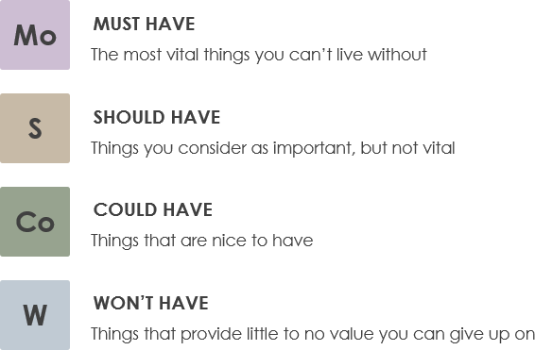

The MoSCoW method prepared for my project is shown in table below:

|  |  |  |  |
| --- | --- | --- | --- |
| ID | Title | MoSCoW | Description |
| Fr01 | New Shop Registration | Must Have | It is important to register new shop. |
| Fr02 | Login | Must Have | It is important to gain more features from sites. |
| Fr03 | Log Out | Must Have | User should get out at their free will to be more secure. |
| Fr04 | Shoes Rating | Should Have | This helps people to get top shoes but different people have different likes. |
| Fr05 | Details Of Item | Must Have | Customers must be able to know the details of shoes. |
| Fr06 | Online Order | Must Have | Shops must be able to online for better deal. |
| Fr07 | Online Payment | Must Have | They must be able to do online transaction for safe receiving and payment. |
| Fr08 | Add New Item | Must Have | New shoes must be able to add in the site. |
| Fr09 | Edit/Update Profile | Must Have | User must be able to edit or add new information. |
| Fr10 | Edit/Update Item | Must Have | Admin must be able to edit the details of item if any change made in the item. |
| Fr11 | Remove Item | Must Have | Admin must be able to delete the old item which are stopped manufacturing. |
| Fr12 | Deleting Shop Membership | Must Have | Admin must be able to delete the users after membership is closed. |
| Fr13 | Review | Should Have | Customer should be able to comment about the shoes. |
| Fr14 | Fast Order | Must Have | Shops must be able order fast for better customer satisfaction. |
| Fr15 | Message | Should Have | Customer and shops should be able to communicate. |
| Fr16 | Shops List | Must Have | Admin must be able to keep track or monitor the users. |
| Fr17 | History Of Shop | Must Have | Admin must be able to all the deals and transaction made with all shops. |
| Fr18 | Community Forum | Should Have | Customer should be able to discuss among themselves. |
| NFr19 | User Friendly | Must Have | Site must be user friendly so everyone can surf easily. |
| NFr20 | Security | Must Have | Everything must be secured for safe transaction. |
| NFr21 | Performance | Must Have | Site must be very responsive no matter how many people are visiting. |
| NFr22 | Maintainability | Should Have | System should be able to fix the bugs and errors. |
| NFr23 | Region Restriction | Could Have | Site could have been banned in other countries. |
| NFr24 | Reliability | Must Have | System must be able to run without failure. |
| NFr25 | Scalability | Must Have | System must have good response even loads is increased. |
| NFr26 | Compatibility | Should Have | Site should be compatible in all device to all browsers. |
| NFr27 | Globalization | Should Have | Site should have the language translation function so that people from all country can surf easily. |
| NFr28 | Documentation | Should Have | It helps in documenting easily. |
| NFr29 | Capacity | Must Have | System must be able to deal with large amount of data from all users. |
| NFr30 | Recoverability | Must Have | Data can be loss anytime so system must be recoverable. |

Table: MoSCoW Prioritization

### 2.4.4 System Requirement Analysis

The System Requirement Specification is a structured collection of information which shows what or how much system needs to work properly. It also shows the details of hardware and software that are required to develop the project properly.

Hardware and Software required for developing my project and after developed to use the product I have listed in a table below:

* Requirements Before project

|  |  |
| --- | --- |
| Software’s | Hardware’s |
| Sublime  Windows 7/8/8.1/10  My SQL Database  XAMPP  Mozilla Firefox/ Google Chrome  Star UML | Laptop/ PC  RAM (4Gb+)  Up to 100GB free Hard Disk Space |

* Requirements/Specification

|  |  |
| --- | --- |
| Software’s | Hardware’s |
| For PC/Laptop:  Windows 7/8/8.1/10  For Mobiles:  Android 4.0+  IOS 8.0+  Browsers:  Mozilla Firefox, Google Chrome, Safari etc. | Internet Connection  Android OR IOS devices  Laptops OR PC with minimum:  Duo Core Processor  2GB Of RAM  500MB+ Hard Disk Space |

## 2.5 Use Case Diagram

Use Case Diagram is a representation of a user interaction which shows the relation between users with many different use cases where user are involved. Use cases are represented by circles or eclipse. It can identify the different type of users of system and also different use cases and often accompanied by other types of diagrams also.

The advantages of using use case are as follows:

* It helps in capturing the requirements of system and validation the system architecture.
* It helps in specifying the system context and implementation of drive and generate test cases.
* It helps to understand system and process well.
* It also show the relations between different functions.

Use case diagrams that I have made for my project are as follows:

* Admin Login

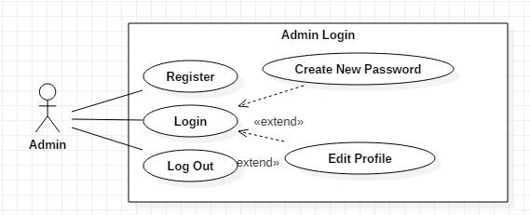

Screenshots: Use case Admin Login

Here, Admin can Login into their profile. If there is new admin without account they can create new profile. They can also change their password and edit/update their profile if needed. They can also log out form their profile free will.

* Admin Functions

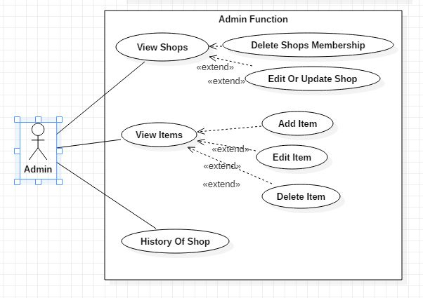

Screenshot: Use case Admin Functions

Here, after logging in admin will also have many features they can do. They can see the list of all members shop. They can delete the shops membership and edit/update the information of shop if any change made by shops. They can also see all the shoes manufactured in factory. They can add new shoes, edit/update the shoes and delete the shoes which have been stopped manufacturing. They can also see all history with transaction made with shops.

* Members Login

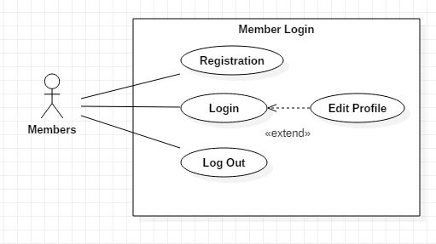

Screenshot: Use case members login

Here, Members can Login to their account and if new shops want to register their shop then they can do it. Members can also edit/update their profile where they can change password, and can change personal information. They can freely log out of their profile.

* Features Of Visitors and Members

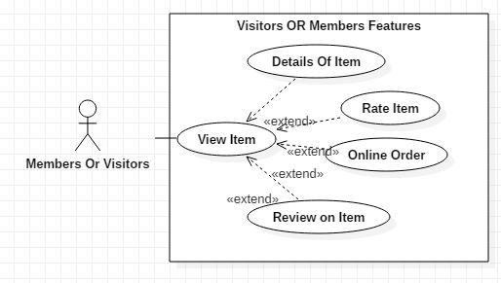

Screenshot: Members Or Visitors Functions

Here, as we know besides shop members visitors and customers can also visit the website. So they can view all the shoes available in factory. They can also see the detail of shoes, give comment on the shoes and rate the shoes. But only Shops members can order the shoes because it requires login function.

* Members Ordering Shoes

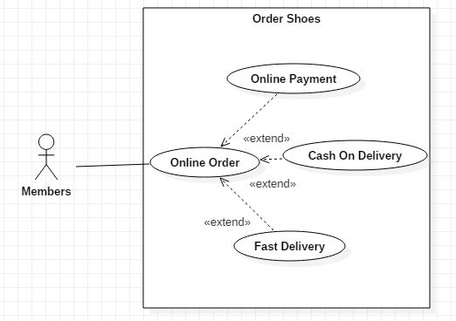

Screenshot: Member Order Function

Here, after clicking on Online Order like shown in above screenshot. Members can book the shoes according to their needs. They can use the fast delivery function and give the time details up to when they needs the shoes to be delivered. They can also pay after delivering with cash or pay online with bank account, e-sewa etc.

## 2.6 NLA and Initial Class Diagram

ABC shoe factory is one of the top shoes manufacturing company of Nepal. It manufactures many designs of shoes which are in trend. It also manufactures the copy of top companies shoe like Nike, Adidas etc. But the current system of this factory is not good responsive with very low features so the company have asked me to make better system for company.

For making better system I have add many new features to make new system better. As we know in today generation people prefer online so I have added many online features to make better system like: User can register(which holds Shop name, owner name, shop location, phone number, e-mail, password will be saved in database) their shop and can login to our websites. They can Order the shoes online, and pay online. They can also edit/update their profile if needed and cancel the membership any time. They can also message which will be viewed by admin. Customer can visit the websites to view the details of shoes, rate the shoes, comment on the shoe. Customer can also discuss among them in community forum. Now Admin can Login and View all the Shop members and delete the Shops who have cancelled their membership. They can also check the transaction made with Shops. They can View Items, Add New Item, Edit/Update Item, and Remove Item.

I have decided to add these features for now but system it will be keep on upgrading to new features.

NLA for my scenario is shown in table below:

|  |  |  |
| --- | --- | --- |
| Candidate Classes | Candidate Attributes | Candidate Methods |
| Shoes  System  Admin  Database  Users | Is  Name  E-mail  Location  Phone Number | Edit  Update Add  Remove  Delete |

Table: NLA OF Scenario

Initial Class Diagram

Class diagram is an illustration of relationships and source code dependencies among classes in UML (Unified Modeling Language). Here classes are arranged in groups which have common characteristics. It resembles a flowchart where classes are kept in boxes which have three box inside where top contains name of class, middle contains attributes and bottom contains operations. Lines is used to connect many boxes which have relationships between the classes.

Class Diagram for my project is as follows:

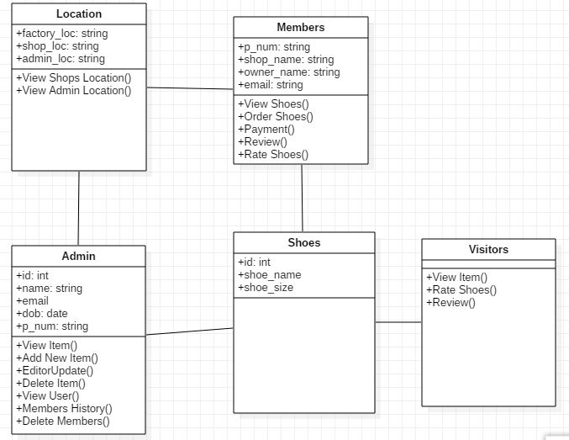

Screenshot: Class Diagram

# Chapter 3

# Design

It is the third stage of software development life cycle (SDLC) which is very important to start implementation or coding stage. It is the most crucial phase in SDLC. In this stage SDLC process continues to move from what questions of analysis stage to the how. In the design stage the programming language, hardware, software platform in which new system will run are also decided.

Importance of design in my project are as follows:

* It helps in contingency, training, maintenance and make operational plan for my project.
* It helps my projects SRS documents into logical structure that contains details and complete set of specification that can be implemented.
* It helps in ensuring the final design has meet the requirements in SRS document.
* Finally it helps in preparing the design documents which will be used in next stage.

For my Project I will be designing following models:

* Structural Model.
* Behavioral Model.
* Architectural Model.
* Database Model.
* Prototype.

## 3.1 Structural Model

Structural Model is a model that exhibits the boundary level that would cause a default considering value of assets and capital. It shows the relations between different components.

### 3.1.1 Final Class Diagram

Class diagram is an illustration of relationships and source code dependencies among classes in UML (Unified Modeling Language). Here classes are arranged in groups which have common characteristics. It resembles a flowchart where classes are kept in boxes which have three box inside where top contains name of class, middle contains attributes and bottom contains operations. Lines is used to connect many boxes which have relationships between the classes.

It’s important for project because of following reasons:

* It helps in analysis and design of static view of my system.
* It helps to describe the responsibilities of individual system.
* It helps to deploy the diagrams we made easier.



### 3.1.2 Flow Chart Diagram

Flowchart is a diagram that depicts a process, system or computer algorithm. It is sometimes spelled as flowcharts, which uses rectangles, oval, diamonds and potentially numerous other shapes to define the type of step.

I have used it in my project because of following advantages in my project:

* It helps to visualize the multiple progress and their sequence in single document.
* It helps to eliminate the unnecessary steps.
* It helps to show only the required steps to reach the end fast.

Symbols used for Flowchart diagram are:

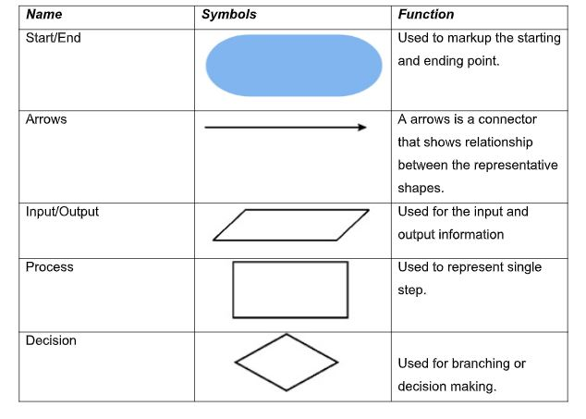

Screenshot: Symbols Details

All the flowcharts for my projects are:

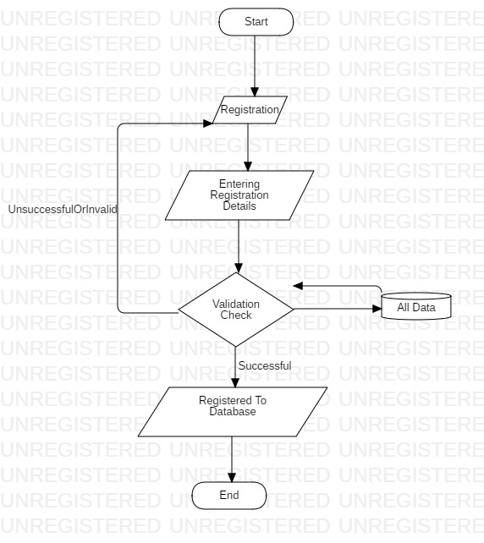

Screenshot: Flowchart for Registration

In the above diagram Admin and Shop or Customers can register to get login access. They must fill the form or details required. After that system checks if the given details are valid or not and if it’s not valid it will take back to registration page and if details are valid then registered to database.

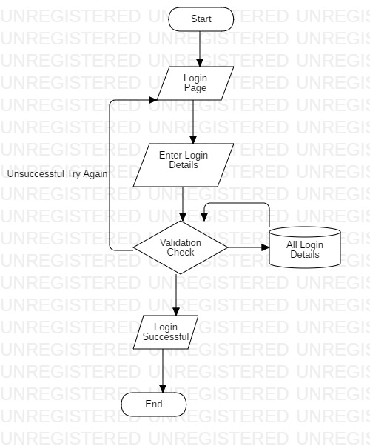

Screenshot: Flowchart Login Page

In the above diagram Users can use their details to login but if the details are invalid it will reload login page and if details are valid users will reload to their dashboard.

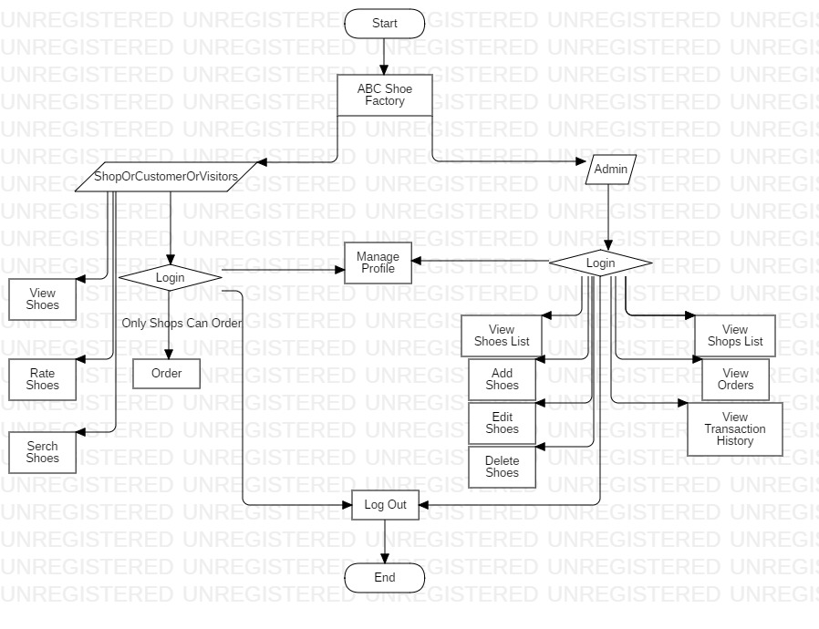

Screenshot: Flowchart Of Admin And Shops Dashboard

In the above diagram, there are two types of users. Firstly, after Shops or Customers logged in they can order shoes edit profile but for viewing shoes no login required.

Finally after admin are logged in they can View list of shoe, add new shoes, edit shoes, delete shoes. They can also see the list of profile of shops, view orders and transaction made with shops.

## 3.2 Behavioral Model

It is a behavioral approach to systems theory and control the theory which was established in 1970 by J. C. Willems. It helps in resolving inconsistencies present in classical approach. Its important feature is that it does not distinguish between input and output variables.

### 3.2.1 Activity Diagram

Activity diagram is a diagram which is also one of important behavioral diagram which describes the dynamic aspects of the system. It is advanced form of flowchart which models the flow of one activity to another.

Features of activity diagram in my project are:

* It helps to describe the parallel, branched and concurrent flow of system.
* It helps to outline the high level activity in system.
* It helps in investing the system in later stage.

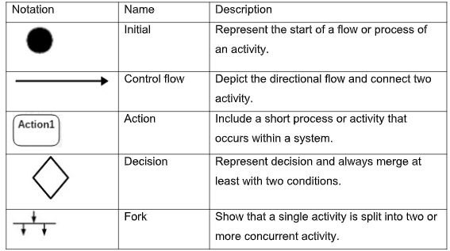

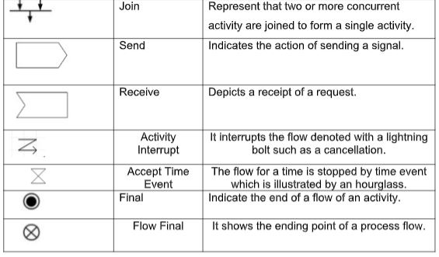

Screenshots: Symbols used in Activity Diagram

1. Login and Registration

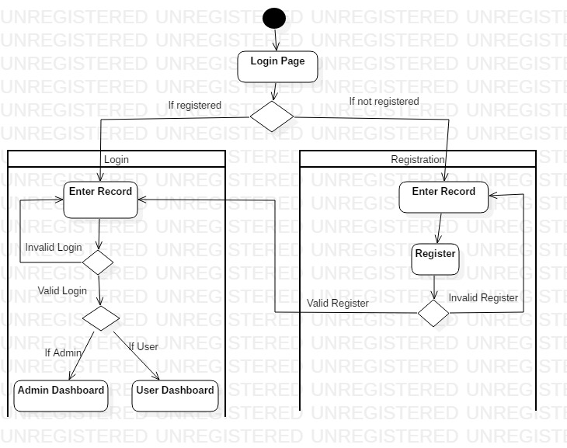

Screenshot: Activity Diagram

Here admin and shops or customer can register the account with the detail required which will be saved in database. So they can also login to the system to get the more function where admin member will login to the admin dashboard and shops or customer will login to the customer dashboard.

2) Admin Function

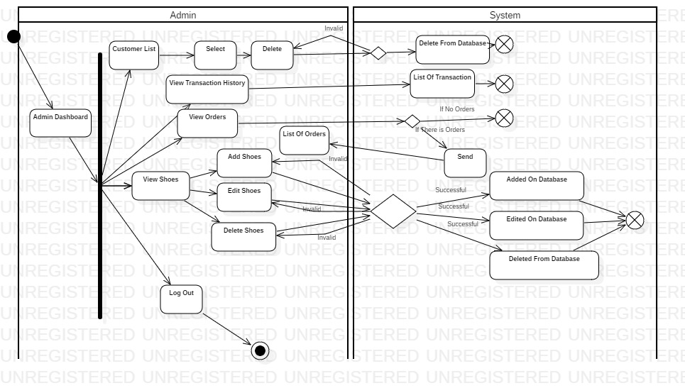

Screenshot: Activity Diagram

Admin can do various function after logged in. They can view the list of customers and delete also. They can see all the transaction made with shops also. The view the list of shoes, add new shoes, edit shoes, delete shoes and see all the order also. Finally they can logout from system.

3) Shops function

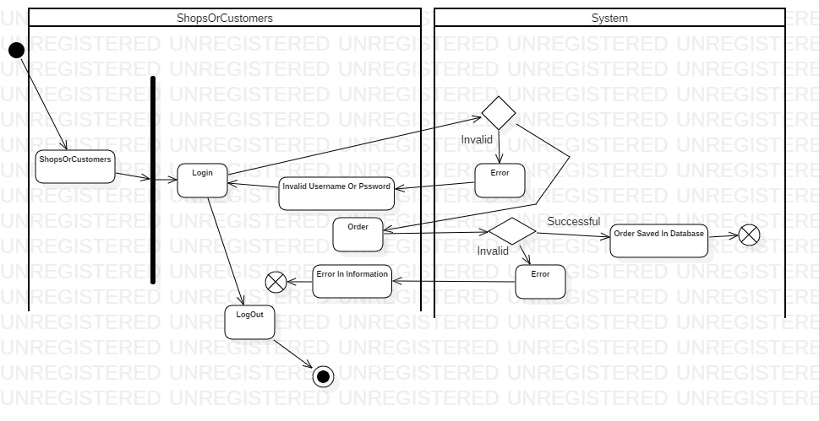

Screenshot: Activity Diagram

In above diagram after logged in shops can order the shoes. It will process in system and if any error found in information they must do process again and if no error found their order will be saved in database.

4) Manage Profile

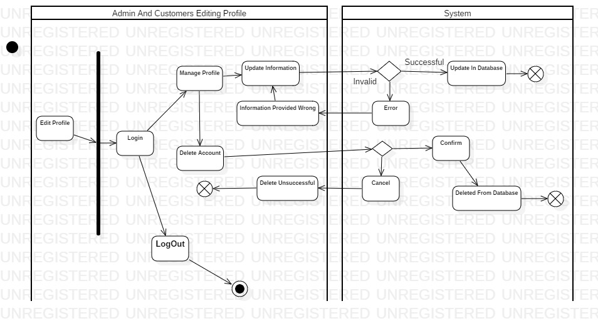

Screenshot: Activity Diagram

In above diagram, admin and customers can login their profile. They can manage profile and edit or update the information they want. They can also delete their account from manage profile if they want. And finally they can logout.

### 3.2.2 Sequence Diagram

Sequence diagram is diagram that shoes the object interactions arranged in time sequence.

Features of sequence diagram in my project are as follows:

* It helps in high level interaction between user of the system and the system, between system and other systems or between sub systems.
* It helps in interaction between objects within a collaboration that realizes an operation.

Notation used in my diagram are as follows:

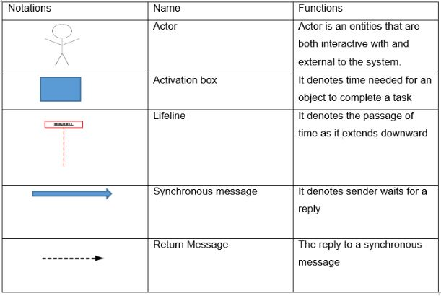

Screenshot: Notation Used in Sequence Diagram

Sequence diagram for my project are as follows:

1. Registration

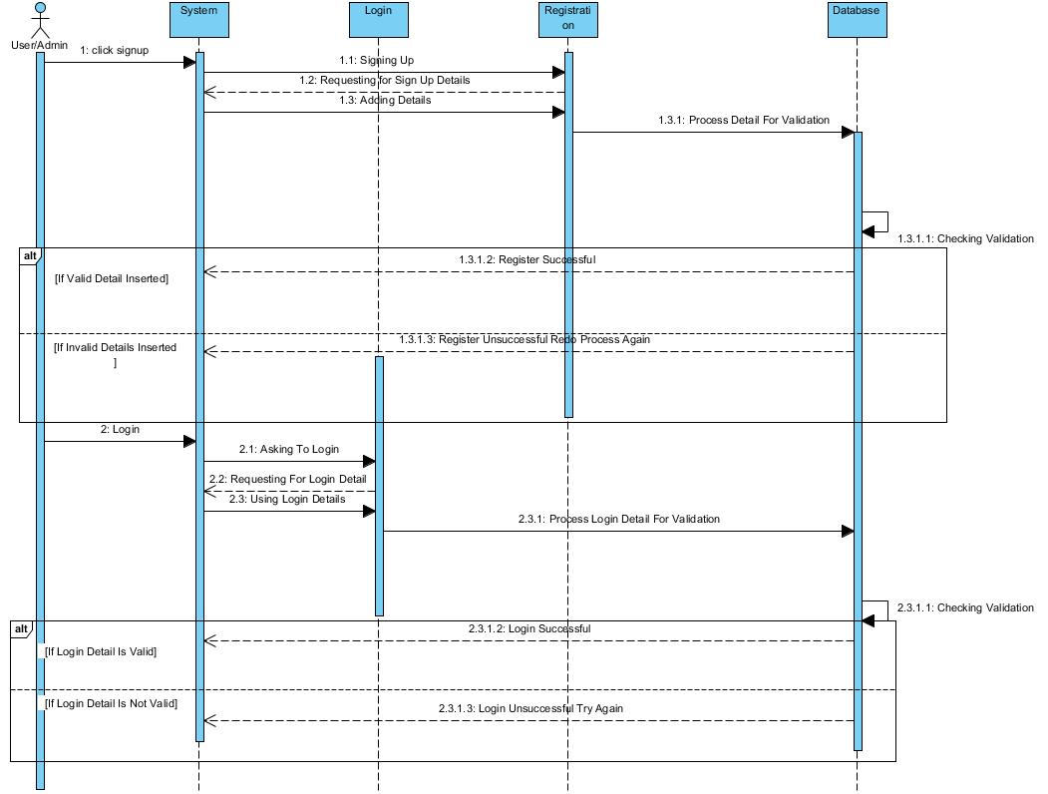

Screenshot: Sequence Diagram

In above diagram, all user admin and shops or customers can register and make profile which will added in data base. They can also login with the details the used to register. They can also logout.

1. User Manage Profile(Admin and Customers)

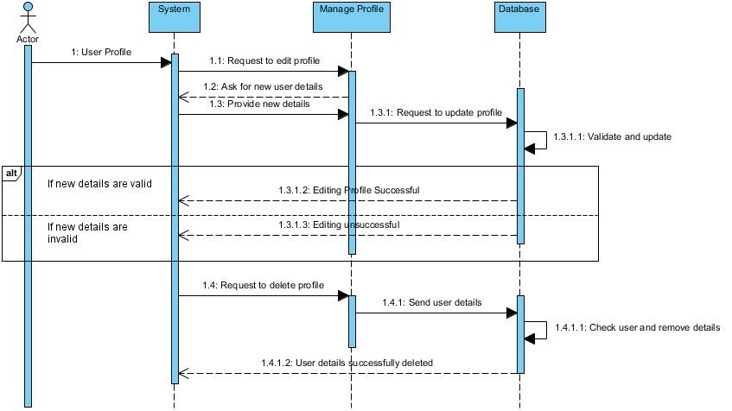

Screenshot: Sequence Diagram

In the above diagram, all the users admin, shops or customers can manage profile and edit their information and also can delete their profile from database.

1. Admin Functions

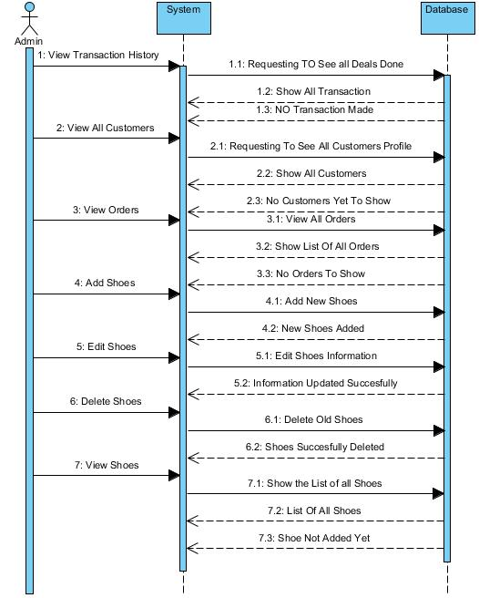

Screenshot: Sequence Diagram

In the above diagram, it show the function of admin where they can view all the transaction made. They can see the accounts of shops or customers, see all the orders made by shops. They can also add new shoes, edit the shoes, delete shoes and see the list of all shoes.

1. Shops Or Customers Function

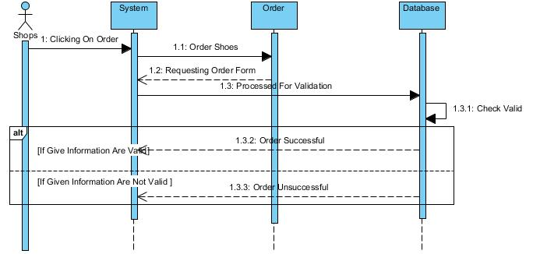

Screenshot: Sequence diagram

In above diagram, Shops can Order the shoes online and the order will be saved in database where admin can see later.

## 3.3 Database Modeling

Database model is the type of data model that determines the logical structures of a database and determines in that manner where data can be organized, manipulated and stored. One of the popular example of database model is relational model which uses table format.

### 3.3.1 Data Dictionary

A data dictionary or metadata is defined as centralized repository of information about data as meaning relationships to other data, origin, usage and format as defined in IBM dictionary of Computing. Oracles defines it as collection of tables with metadata.

Admin and Shop/Customers Registration Table

|  |  |  |  |  |
| --- | --- | --- | --- | --- |
| Name | Datatype | Length | Constraint | Null |
| admin_id/customerid | integer | 1000000 | Primary Key | Not Null |
| name | varchar | 100 | - | Null |
| phone_num | varchar | 20 | - | Null |
| membertype | varchar | 25 | - | Null |
| email | varchar | 80 | - | Null |
| address | varchar | 100 | - | Null |
| password | varchar | 255 | - | Null |

Shoes Registration Table

|  |  |  |  |  |
| --- | --- | --- | --- | --- |
| Name | Datatype | Length | Constraint | Null |
| shoesid | Integer | 1000000 | Primary Key | Not null |
| shoesname | Varchar | 50 | - | Null |
| details | varchar | 255 | - | null |

Online Order Table

|  |  |  |  |  |
| --- | --- | --- | --- | --- |
| Name | Datatype | Length | Constraint | Null |
| orderid | integer | 1000000 | Primary Key | not null |
| shoesname | varchar | 255 | - | null |
| shoesqty | varchar | 255 | - | null |
| address | varchar | 100 | - | null |
| shopname | varchar | 100 | - | null |
| phonenum | varchar | 20 | - | null |

Transaction History Table

|  |  |  |  |  |
| --- | --- | --- | --- | --- |
| Name | Datatype | Length | Constraint | Null |
| transid | integer | 1000000 | Primary Key | not null |
| details | varchar | 500 |  | null |

Admin_Customer Table

|  |  |  |  |  |
| --- | --- | --- | --- | --- |
| Name | Datatype | Length | Constraint | Null |
| Adminadminid | integer | 1000000 |  | not null |
| Customercustomerid | integer | 1000000 |  | not null |

Admin_Shoes Table

|  |  |  |  |  |
| --- | --- | --- | --- | --- |
| Name | Datatype | Length | Constraint | Null |
| Adminadminid | integer | 1000000 |  | not null |
| Shoesshoesid | integer | 1000000 |  | not null |

Customer_Online_Order Table

|  |  |  |  |  |
| --- | --- | --- | --- | --- |
| Name | Datatype | Length | Constraint | Null |
| Customercustomerid | integer | 1000000 |  | not null |
| Online_Orderorderid | integer | 1000000 |  | not null |

Admin_Transaction History Table

|  |  |  |  |  |
| --- | --- | --- | --- | --- |
| Name | Datatype | Length | Constraint | Null |
| Adminadminid | integer | 1000000 |  | not null |
| Transaction_Historytransid | integer | 1000000 |  | not null |

### 3.3.2 ER Diagram

ER diagram (Entity Relationship Diagram) describes the interrelated things of interest in a specific domain of knowledge. ER diagram is composed of entity types which specifies the relationships that exist between entities. Each entities holds attributes and its data types.

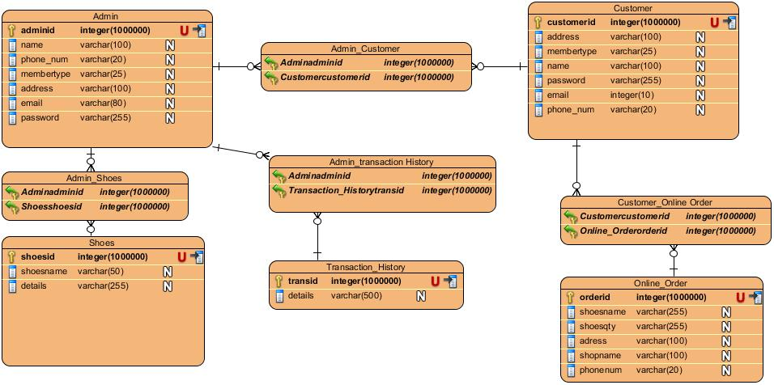

Screenshot: ER Diagram

## 3.4 Architectural Diagram

I have used peer to peer architecture to develop my project. It is one of the commonly used architecture in which each workstation, or node, has the same capabilities and responsibilities. Often it is compared and contrasted to classic client/server architecture.

Advantages of the architecture for my project are as follows:

* It is easy to set up and configure the computer in this network.
* Cost is very low to set up P2P network architecture.
* No need of full time system administrator.
* Central dependency is eliminated so it is more reliable.

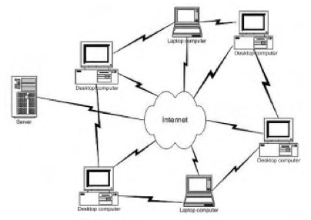

Screenshot: Peer to Peer architecture

## 3.5 Prototype

Prototype is a sample, model of a system which is made to test a concept or process or to act as a thing to be replicated or learned from. There are many type of prototypes and among them I am using Visual Prototype. It represents the appearance, but not the functionality of intended design.

Prototype I have made for my system are as follows:

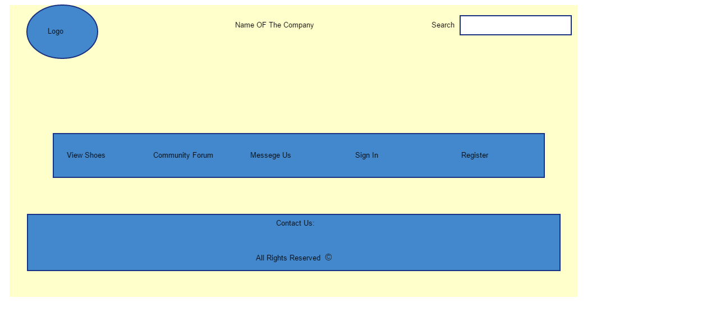

Screenshots: Prototype Home page

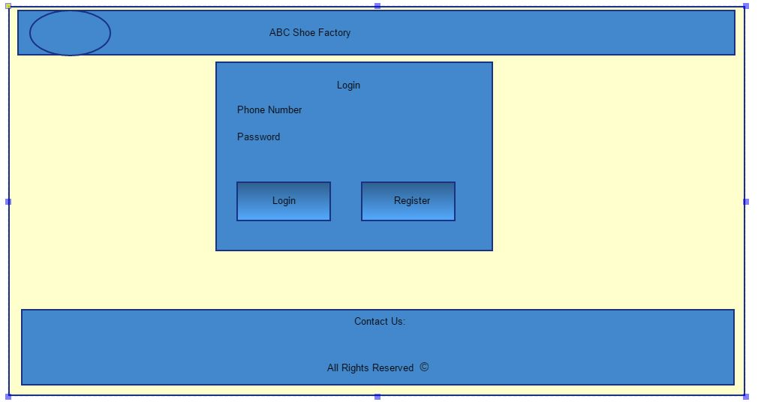

Screenshots: Prototype Login Page

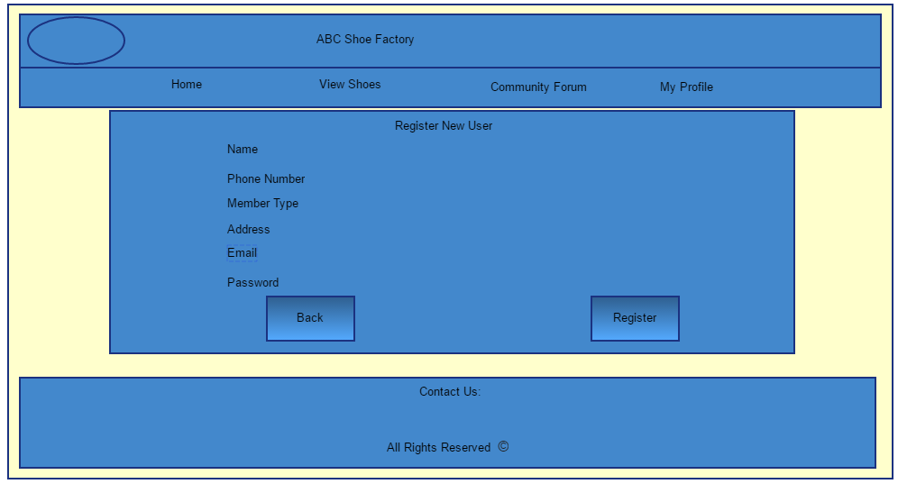

Screenshots: Prototype Register Page

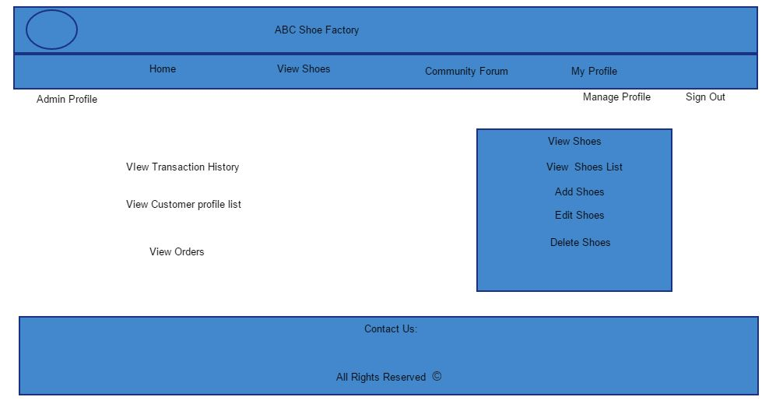

Screenshots: Prototype Admin Dashboard page

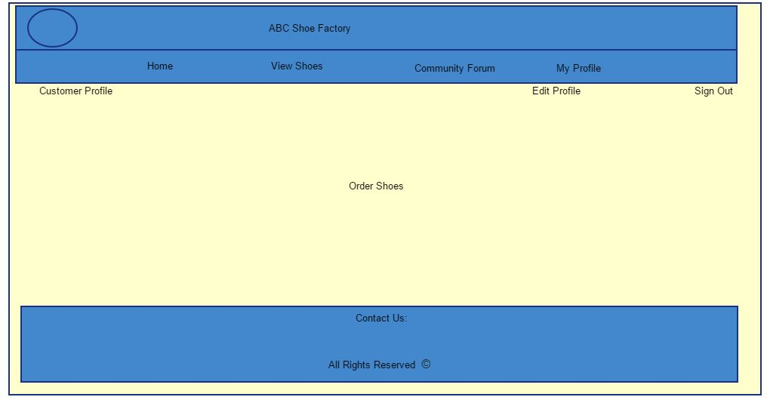

Screenshots: Prototype Customer Dashboard Page

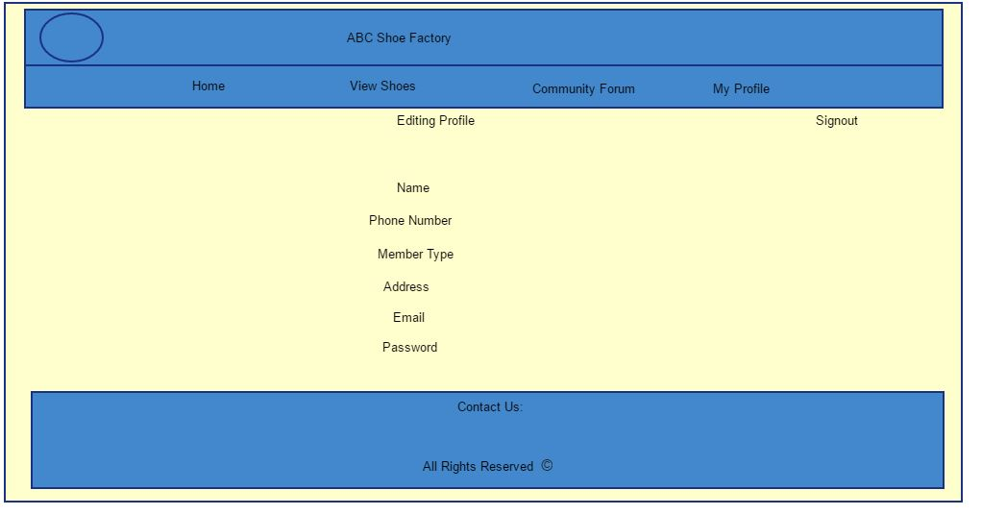

Screenshots: Prototype Manage Profile page

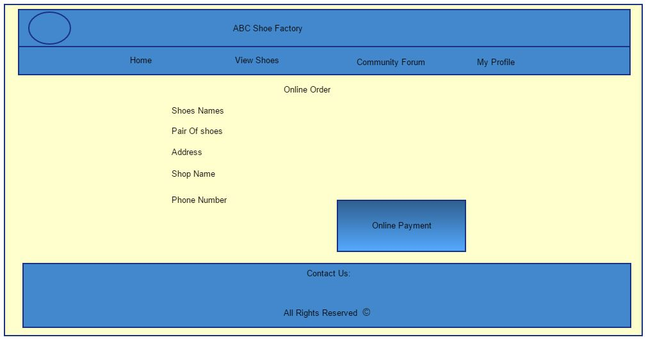

Screenshots: Prototype Order Page

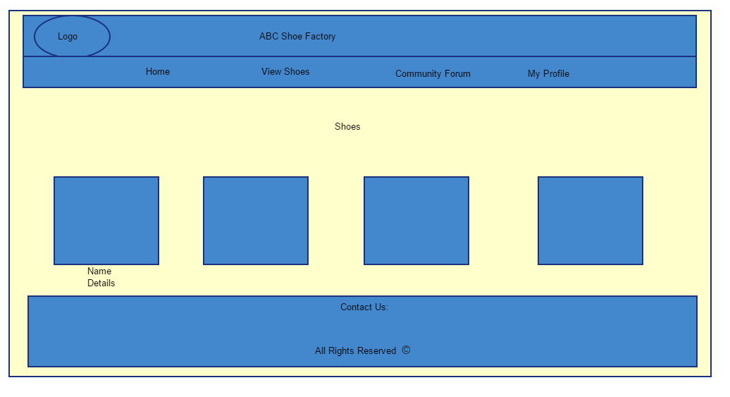

Screenshots: Prototype View Shoes Page

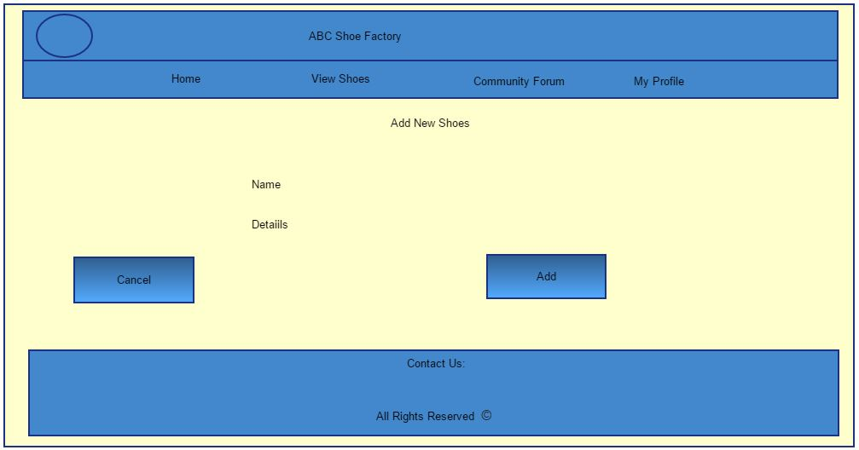

Screenshots: Prototype Add Shoes page

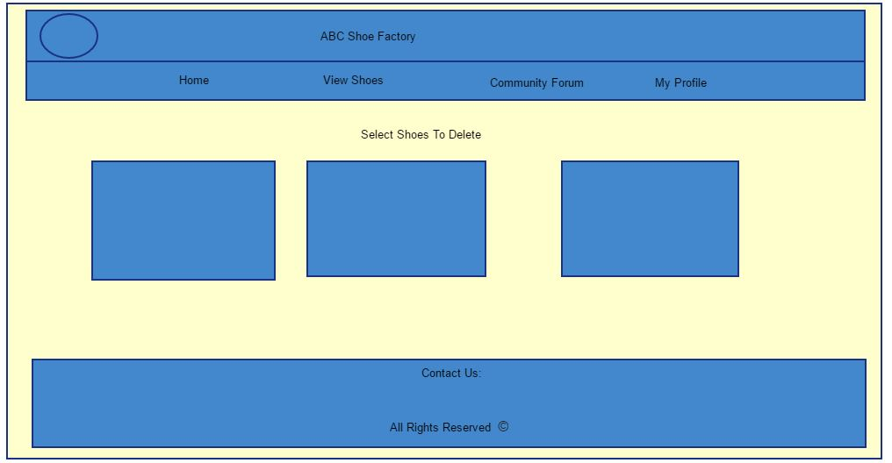

Screenshots: Prototype Select to delete page

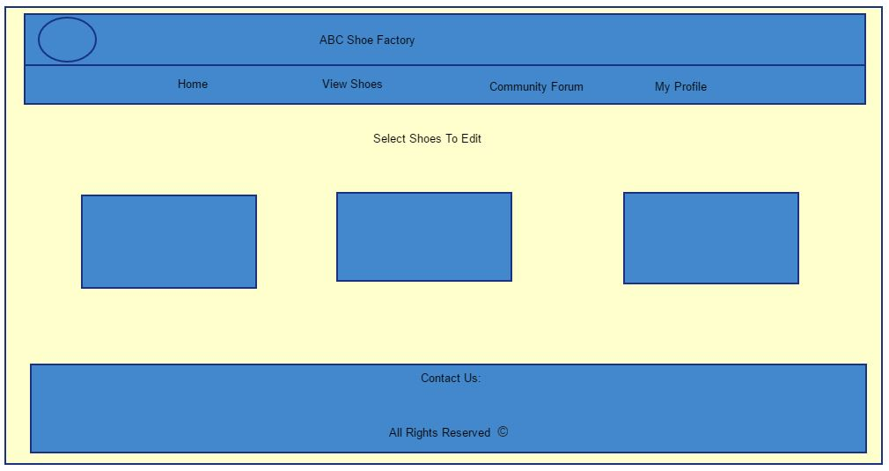

Screenshots: Prototype select to edit page

# Chapter 4

# Coding

## 4.1 Introduction

It is the process of designing and building an executable system to accomplish a specific task. There are many ways to do programming like PHP, Java, C++ etc.

I am developing website for the ABC Shoe factory. So I have choose PHP to do my coding. I am using OOP (Object Oriented Programming) code with MVC pattern to develop the website. I have use XAMPP apache for server and SQL to save all the data.

All the codes used to complete my project are as follows:

All Action Codes:

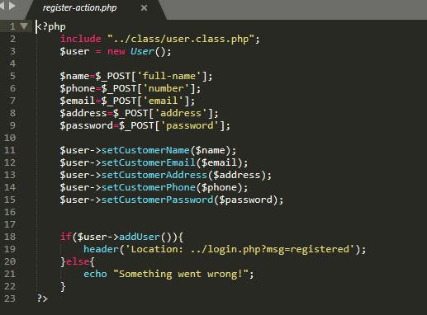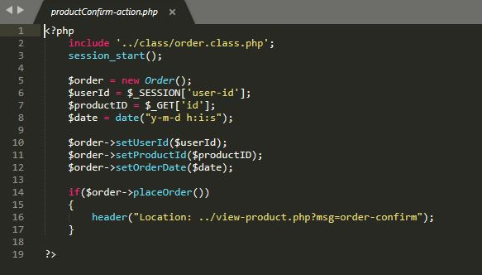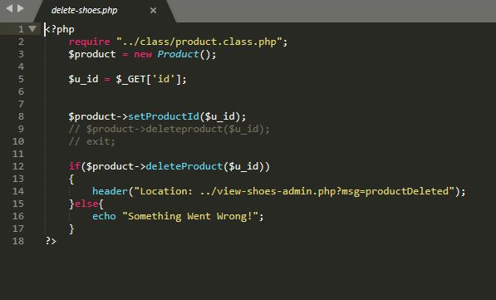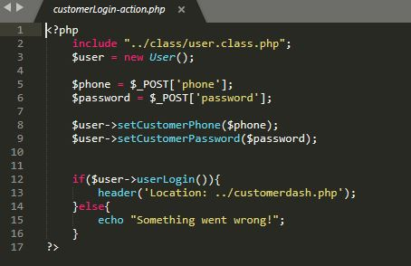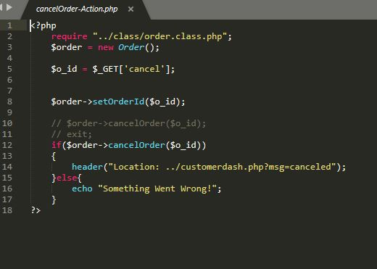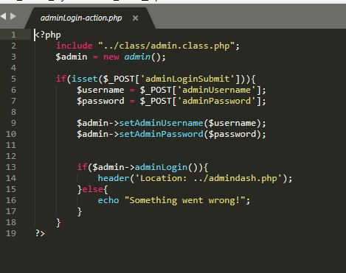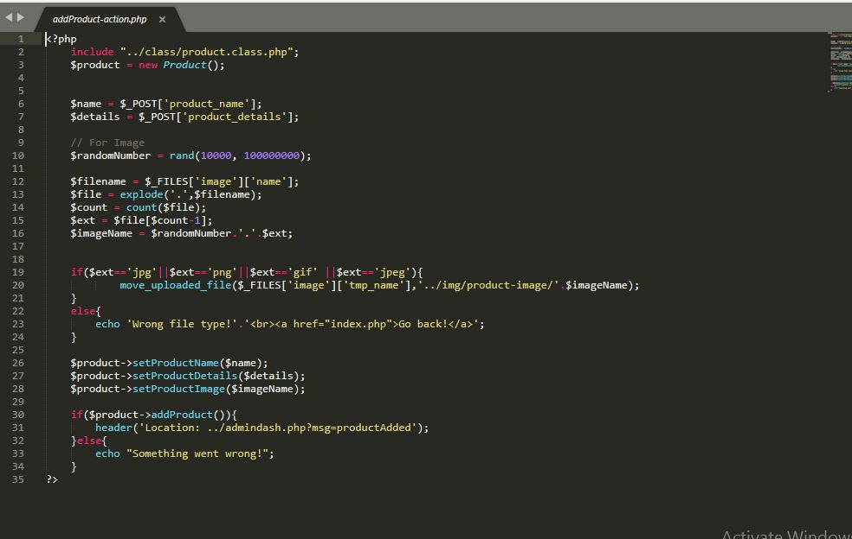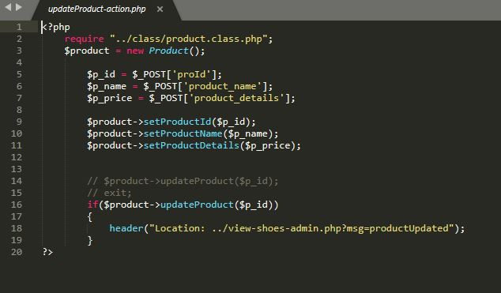

All includes codes: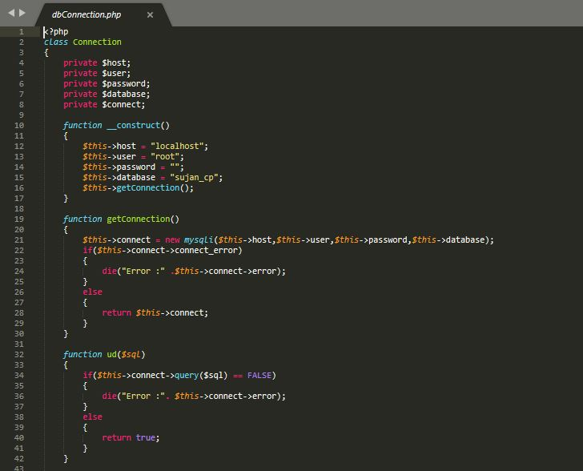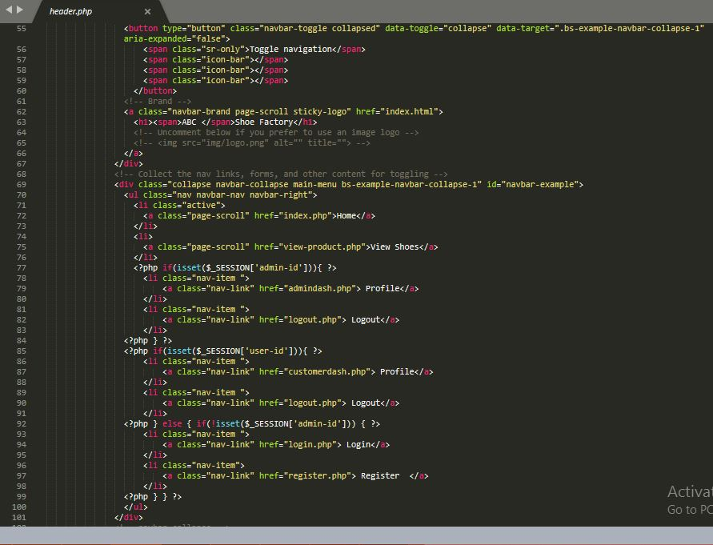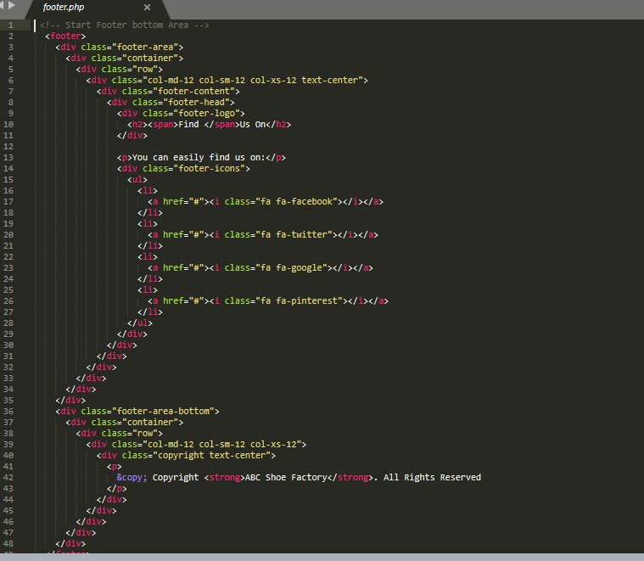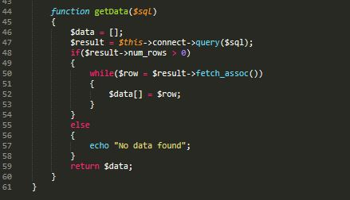

All HTML codes

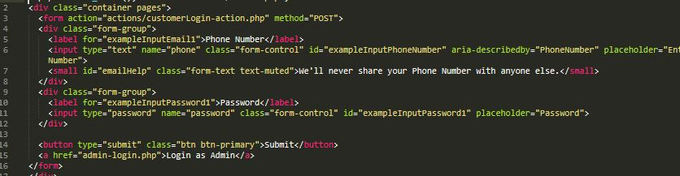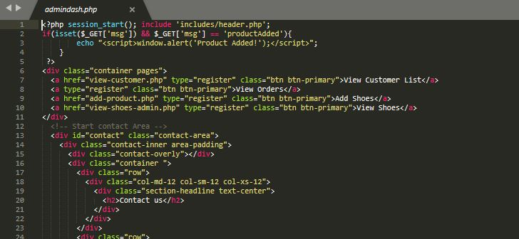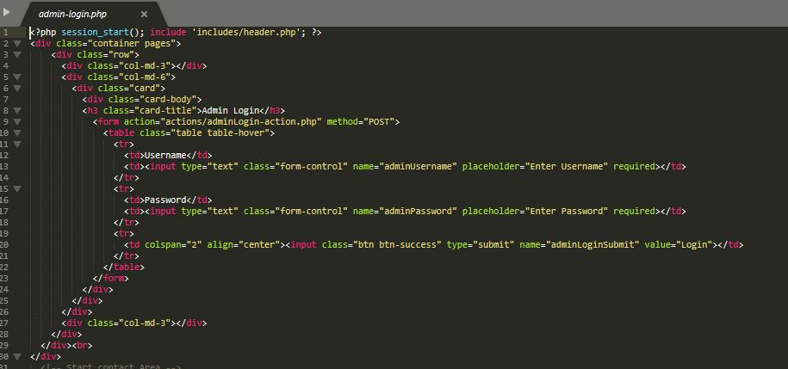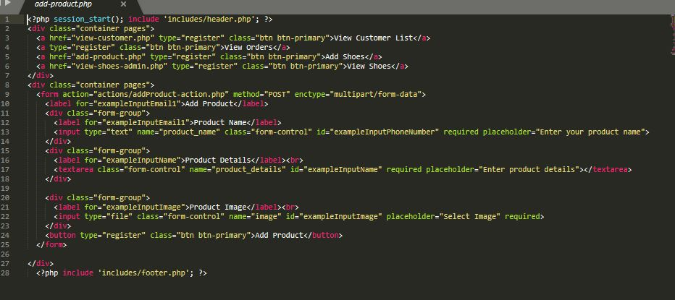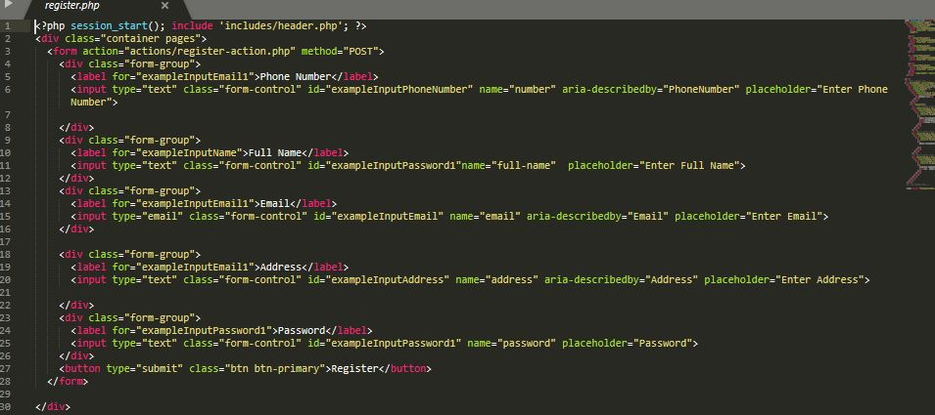

# 

# Chapter 5

# Testing

## Introduction

It is the process of checking whether the actual results match the expected results and also to ensure that system is defect free. It also helps in identifying errors or missing requirements to the actual requirements. It can be done with automated tools or manually. In simple terms system testing means Verification of Application under Test (AUT).

## 5.2 Types of Testing

There are different types of testing which have its own good feature. Some types of testing are Unit Testing, White box testing, Black Box testing etc.

### 5.2.1 Black-Box Testing

It is the process of system testing that examines the functionality of the system without peering into internal sources. There are different types of black-box testing like functional testing, non-functional testing and regression testing. I have done some testing on some features:

|  |  |  |  |  |  |
| --- | --- | --- | --- | --- | --- |
| ID | Test Scenario | Test Data | Expected Result | Actual Result | Result(Pass/Fail) |
| t1 | User Register And Data saved In database | Phone Number, Name, Address, Password | If Everything Is Correct Data Register Successful | Registration Successful | Pass |
| t2 | Customer Login | Phone Number, Password | If Data is valid Login Successful | Login Successful | Pass |
| t3 | Edit Profile | Phone Number, Name, Address, Password | Inputted Data valid change data in database | Edit Successful | Pass |
| t4 | Order | Oder Button | If customer clicks on order button shoe must be ordered | Order successful | Pass |
| t5 | View Customer List | All Data Of customer | Show the list of customer | Showing All Data | Pass |
| t6 | View All Orders | All the Orders Made by Customers | Show all the orders | Showing all orders | Pass |
| t7 | Add Shoes | Name, Detail, Image | If data are valid Add successful | Add successful | Pass |
| t8 | Edit Shoes | Name, Detail, Image | If Data are valid change in database | Edit Successful | Pass |
| t9 | Delete Customer | Delete | Delete Customer Data | Delete Successful | Pass |
| t10 | Delete Shoes | Delete | Delete Shoes | Delete Successful | Pass |

# Chapter 6 Issues

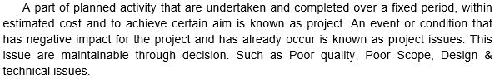

## 6.1 Project Issues

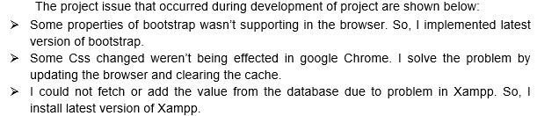

## 6.2 Limitation

* Urban areas people can’t visit website.
* Focused only in a country.
* Other countries beside Nepal cannot place any order for now.

## 6.3 Risk Management

Risk Management is the process of identifying, accessing and controlling threats of organization or company or project etc. Risk can arise from various cause so we must find solution instantly instead of delaying it. There is not anything without risk and it will make impact. So like that my project also have risk but overcome or trying to overcome that risk is called the complete project. We cannot overcome all the risk that arises.

I am going to list some risk that might occur and will give the prevention or solution to minimize or solve the risks through the table below:

First let me give the value for the Probability of risk occurance and impact of that risk.

|  |  |
| --- | --- |
| Probability | Value |
| Very High | 5 |
| High | 4 |
| Medium | 3 |
| Low | 2 |
| Very Low | 1 |

Table : Risk Probability Value

|  |  |
| --- | --- |
| Risk Impact | Value |
| High | 3 |
| Medium | 2 |
| Low | 1 |

Table : Risk Impact Value

Now let’s start the table which will show some risk that might occur and solution for it:

|  |  |  |  |  |  |
| --- | --- | --- | --- | --- | --- |
| S/N | Risk | Probability | Risk Impact | Value (Probability*Risk Impact) | Prevention OR Solution |
| 1 | Loss Of Data | 2 | 3 | 6 | Backing of data in GitHub, cloud, external hardrive etc. |
| 2 | Project Deadline | 3 | 3 | 9 | Managing the time according the milestone or gantt chart. |
| 3 | Project Acceptance | 3 | 3 | 9 | Making it more user friendly or making full tutorial video. |
| 4 | Team Health Condition | 3 | 2 | 6 | Check Up health In a week, keeping of replacement. |

Table : Risk with Solution

## 6.4 Configuration Management

Configuration Management is not the exiting topic but it is most essential for success of the project. It helps in managing, controlling, protecting the projects. (StakeholderMap, 2019) It keep or record all the files and document of the project. It helps to keep our data safely.

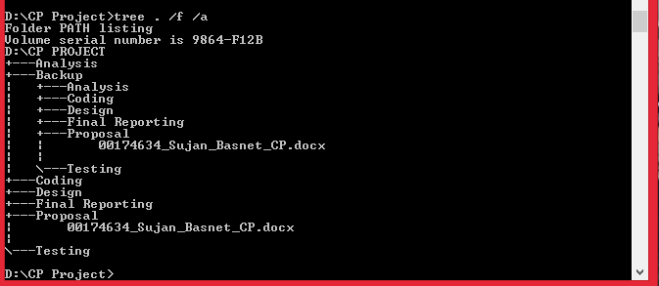

Screenshot: Tree

I have made different folder for the different phase of project to hold. I have also made backup folder which holds all my phases of project in case of any loss of data in future.

# Chapter 7 Future Work

Future works are the works which are separated to do in future after the completion of system as update or upgrade. There are still many features need to be added. It helps to make system more advanced. I am going to list the few future works:

Verification: Right now I haven’t made verification system yet so anyone can login.

Forget Password: It helps to customer to renew password incase if they forget their password through verification method.

Online Payment: Customer can pay online rather than paying on cash on delivery.

Above mentioned are not enough as future work. There are still more new features to come in future but in next upgrade above features will be added.

# Chapter 8 User Manual

It is a help or manual which will guide the customers to use the website properly.

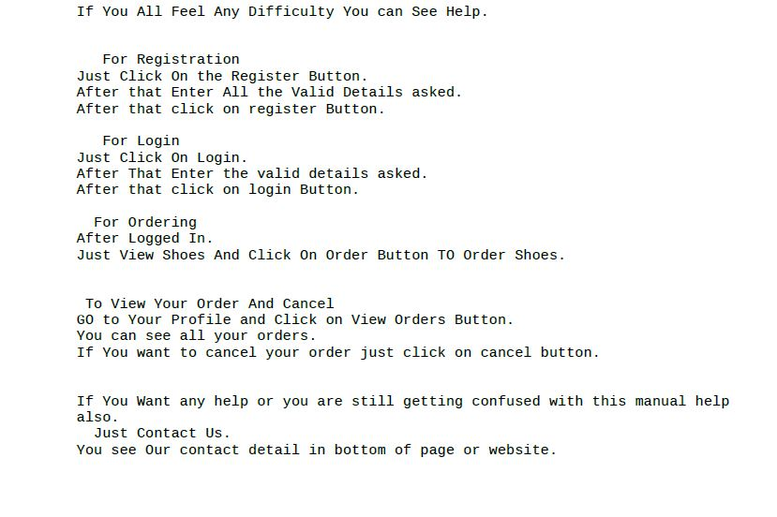

# Chapter 9 Conclusion

Finally the system for ABC shoe factory has been made and applied successfully. It is a factory who delivers shoes to shops and if orders comes it supplies according to order.

I have made class diagram, ER diagram, Sequence diagram and many other diagram to help in my project. I have used PHP XAMPP to complete my codes. There are many issues I face are listed above. I have done black-box testing are also listed above. Still many new features need to be added will come in future.

So, the project was completed successfully.

# References

gantt, 2019. *creating-gantt-charts.* [Online]   
Available at: https://www.gantt.com/creating-gantt-charts.htm  
[Accessed 9 April 2019].

StakeholderMap, 2019. *project-management/configuration-management.* [Online]   
Available at: https://www.stakeholdermap.com/project-management/configuration-management.html  
[Accessed 8 April 2019].

Tutorialspoint, 2019. *SDLC.* [Online]   
Available at: https://www.tutorialspoint.com  
[Accessed 9 April 2019].

Wrike, 2019. *WBS.* [Online]   
Available at: https://www.wrike.com/project-management-guide/faq/what-is-work-breakdown-structure-in-project-management/  
[Accessed 7 April 2019].

Duggan, T. (2018, June 30). *Chron*. Retrieved from Chron: http://smallbusiness.chron.com/risk-management-important-project-success-56920.html

folks, t. (2014, December 10). *softwaretestingclass*. Retrieved from https://www.softwaretestingclass.com/difference-between-black-box-testing-and-white-box-testing/

Hofstrand, D. (2009, October). *Extension*. Retrieved from https://www.extension.iastate.edu/agdm/wholefarm/html/c5-65.html

Bizfluent.com. (2019). [online] Available at: https://bizfluent.com/info-7814909-projectcoding-systems.html [Accessed 26 Jul. 2019].

G uru99.com. (2019). *What is Software Testing? Introduction, Definition, Basics & Types*. [online] Available at: https://www.guru99.com/software-testing-introduction-importance.html [Accessed 26 Jul. 2019].

Guru99.com. (2019). *What is BLACK Box Testing? Techniques, Example & Types*. [online] Available at: https://www.guru99.com/black-box-testing.html [Accessed 26 Jul. 2019].